CRHS Chorus Booster Cinnamon Bun Fundraiser
$ 12 for a package
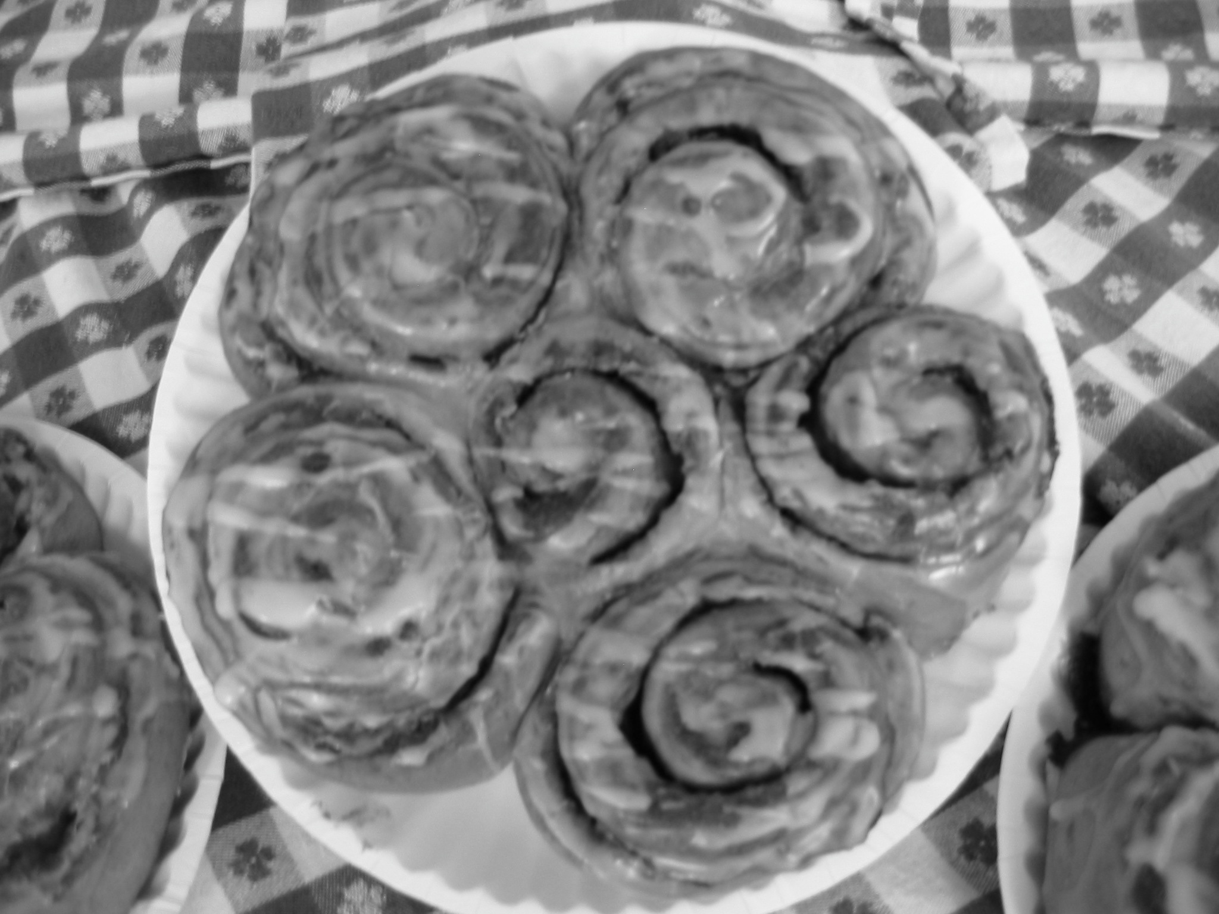
Of 6 buns

Freshly baked cinnamon buns from Tobi’s Bakery in Hillsborough. Made from scratch yeast dough filled with mouthwatering cinnamon and brown sugar filling. Using local organic flour as well as local milk and eggs. Eat them fresh or freeze them for a special occasion.

Student Name:

Name Phone Number # of Items Order price

All orders must be prepaid in cash or check. Order
Make Checks Out to CRHS Chorus Boosters Total

All Orders due by: April 27, 2015

Orders will be delivered on: April 30 & May 1, 2015

